Ionic Liquids Based on Imidazolium Cation in Electrochemical Tantalum Polishing and Nanostructuring
Olga Lebedeva,¹ Natalia Root,¹ Dmitry Kultin,¹ and Leonid Kustov^{1,2}
¹Department of Chemistry, Lomonosov Moscow State University, 119991, Moscow, Russia
²Zelinsky Institute of Organic Chemistry, Leninsky prospect, 47, 119991, Moscow, Russia
The Ionic Liquids (ILs) are the electrolytes meeting requirements of "green chemistry" and are respectively deprived of defects of traditional electrolytes. The process of polishing in IL doesn't demand preliminary mechanical or chemical processing of a metal surface [1]. Tantalum electropolishing was carried out in [BMIM][NTf₂], [BMIM]BF₄ and [BMIM]Cl. The polishing of Ta was performed at a constant current intensity or about at a constant potential. The choice of conditions of polishing was carried out on the basis of the analysis of dependences of transient of current [2].
Synthesis of nanodimensional particles of tantalum oxide was carried out from solutions with additives of water and propylene glycol (the volume relation 1:1). Process was carried out at a temperature 25 C. The IL on the basis of a tetrafluoroborate was the most effective. The surfaces of the samples were studied by SEM technique. Figures 1a and 1b show the formation of the nanostructured features of tantalum oxide. The element analysis has shown the compliance to tantalum (V) oxide.
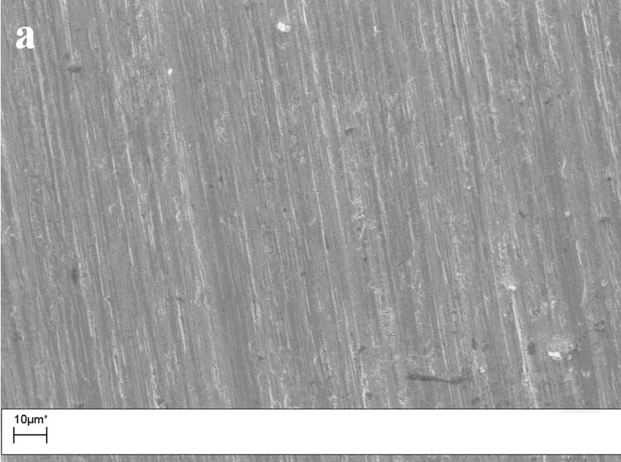 | 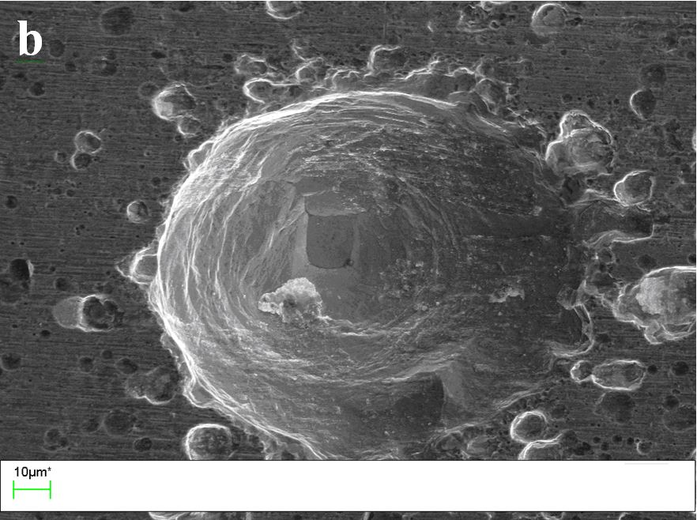
Figure 1. SEM of a surface of initial tantalum (a) and after processing of 2.5 mA current for 600 s (b) in [BMIM]BF₄.
Acknowledgment
This research was supported by the grant of the Russian Ministry of Science and Education No. RFMEFI61614X0012.
References
(1) Lebedeva O.; Jungurova G.; Kultin D.; Kustov L.; Zakharov A.; Kalmikov K.; Chernikova E.; Krasovskiy V. Ionic liquids based on the imidazolium cation in platinum and titanium electropolishing. Green Chem. 2011, 13, 1004–1008.
(2) Neergat M.; Weisbrod K. R. Electrodissolution of 304 Stainless Steel in Neutral Electrolytes for Surface Decontamination Applications. Corros. Sci. 2011, 53, 3983−3990.

